“He is like a Tree
Planted by Streams
of water, which yields
its fruits in season
and whose leaf does
not wither. Whatever
he does prosper.”
-Psalms 1:3

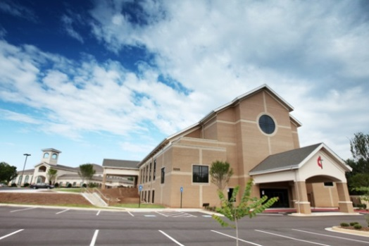
Preschool ● After School:
 678-387-8785
 tpspreschool@yahoo.com
 www.tpspreschool.wixsite.com

KCA UMC 아틀란타 한인교회
3205 Pleasant Hill Rd. Duluth, GA 30096
Senior Pastor담임목사: 김세환
TPS
Tree Planted by Streams
Preschool
After School
Enrichment Classes

TPS Preschool
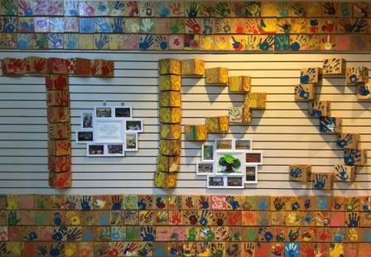
Please inquire for more information regarding tuition and registration fees.
Lunch, two snacks are provided per day. Ballet classes available for an additional cost for 3’s & 4’s.
A typical day includes chapel time, recess, learning time, arts & crafts, lunch, nap time, afternoon enrichment class.
TWO YEAR OLD PROGRAM
Our 2 year old program is designed to introduce children to numbers 1 through 20 and the alphabet, one letter a week.
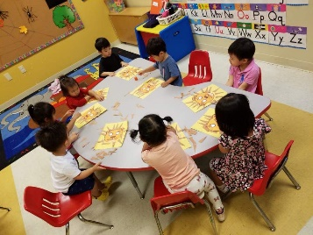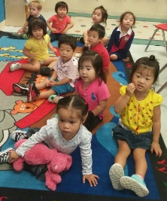
Dramatic Play, and Housekeeping centers are used to reinfornce social skills such as listening and sharing and to promote creativity.
TPS Preschool
THREE YEAR OLD PROGRAM
Letter recognition and phonics are taught, along with one letter each week. Also taught are different colors, shapes, and basic concepts in math and science.
Using hands on materials to reinforce phonics centers play a big role to teach weekly themes and beginning sight words in a fun and dynamic way.
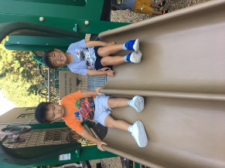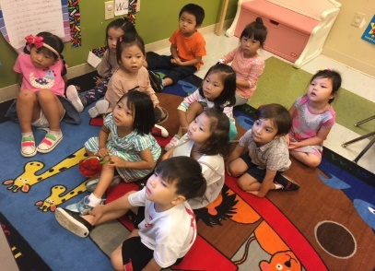
FOUR YEAR OLD / PRE-K PROGRAM
Let’s get ready for Kindergarten! Basic concepts of kindergarten math, sight words and recognizing upper & lower case letters, phonics and more are taught to our 4-year-olds.
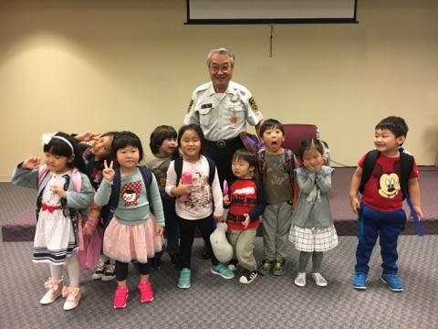
TPS Afterschool
Monday-Friday 3pm – 6pm
Last pick-up at 6:30pm
Available for all Preschoolers
Childcare is also available during most holidays.
3:00 | Arrive
4:00 | Snack
4:30 | Arts & Crafts
5:00 | Recess
6:00 | Dismissal
6:30 | Last Pick-Up

Enrichment Classes
We hope these classes will make it convenient for our parents; students have the opportunity to take lessons at school without having to travel to classes.

Tae-Kwon-Do
Ballet
Art
Music
English
Korean

